**Assignment 9A**

MKT 441-75 | Due 11/13/17

Cailyn Cochran | Paige Ezell | Brevin Woodford

**\*All group members contributed equally to this assignment\***

# Marketing Research

# Assignment #9a

# 25 Points

### For this assignment, use your formatted/coded data set (i.e. after you removed the respondents who failed one or more quality checks)

Please complete the following steps related to the analysis of your formatted data file. This assignment should be completed in **SPSS**. **Cut and paste the SPSS results into WORD for each question.**

**1. Double check that you are using your most current, up to date spreadsheet that only exams the number of respondents that have passed all of the quality check questions.**

Does the sample size for your current spreadsheet match the sample size from Assign 8 for number of respondents who passed all of the quality check questions (Yes or No).

**Yes**

What is the number of respondents who passed all of the quality check questions (type the number below)

**743**

2a. In SPSS, create a table for the attribute ratings showing the mean ratings for Powerade – in rank order. The attributes ratings are those questions asked on a 5 point Likert scale (agree/disagree scale)

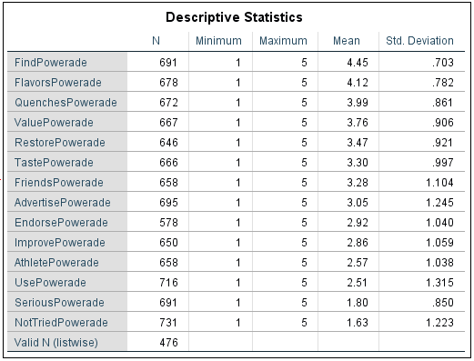

2b. Create the same table for Gatorade attribute ratings – in rank order.

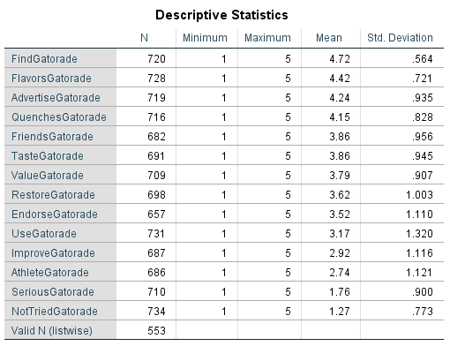

3. Create a simple perceptual map in either XL or SPSS. On this perceptual map, please plot both Powerade and Gatorade on two attributes you think are important. The easiest way to do this is with an XY (or scatter) graph in XL.

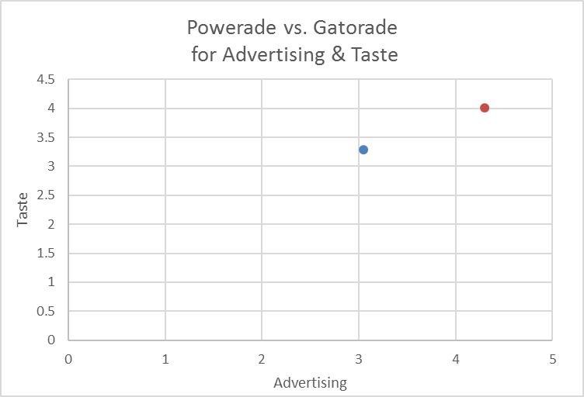

4. Create a single (easy to read) pivot table that compares the mean ratings for the following measures by Powerade triers versus non triers. Your pivot table, as usual, should show sample size

* Satisfaction powerade
* Age (the re-coded variable)
* Income (the re-coded variable)

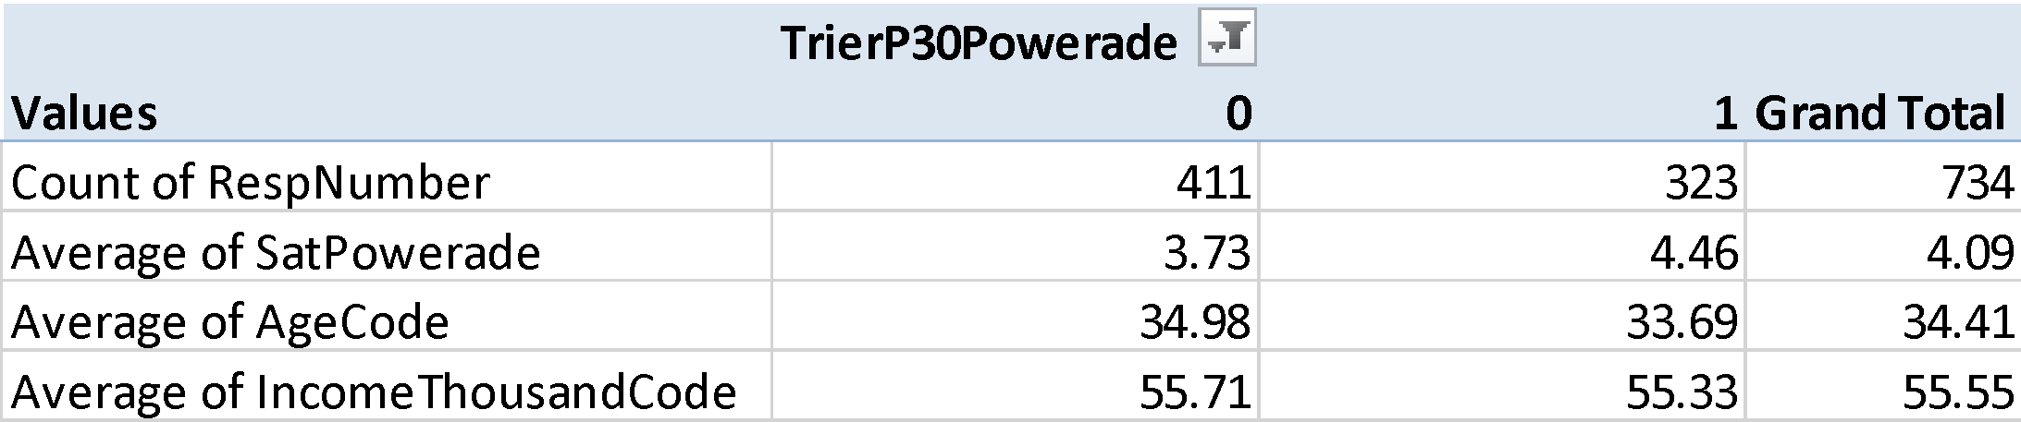

5. Determine if the mean ratings between Powerade triers and non-triers are significantly different for the following measures. To determine if the mean ratings are different by triers and non triers, use the independent sample t-test

Calculate the t-test for each one below using *analyze/compare means/independent samples t-test****.***

**Be sure to copy and paste the SPSS output that shows the MEAN RATINGS.**

* Satisfaction Powerade
* Age (the re-coded variable)
* Income (the re-coded variable)

For **each of the above measures and hypothesis tests**, what is the null hypothesis? what is the alternative hypothesis? Based on the results, do you accept or reject the null hypothesis? Why?

**Satisfaction:**

* **Null Hypothesis: There is no difference in satisfaction by Powerade triers and non-triers.**
* **Alternative Hypothesis: There is a difference in satisfaction by Powerade triers and non-triers.**
* **Based on the results, we reject the null hypothesis and accept the alternative hypothesis because the Sig (2-tailed) data in the SPSS output is .000, meaning we are essentially 100% confident that there is indeed a difference in satisfaction by Powerade triers and non-triers.**

**Age:**

* **Null Hypothesis: There is no difference in age by Powerade triers and non-triers.**
* **Alternative Hypothesis: There is a difference in age by Powerade triers and non-triers.**
* **Based on the results, we reject the alternative hypothesis and accept the null hypothesis, because the Sig (2-tailed) data in the SPSS output is .104, meaning that we are only 89.6% confident that there is a difference in age by Powerade triers and non triers.**

**Income:**

* **Null Hypothesis: There is no difference in income by Powerade triers and non-triers.**
* **Alternative Hypothesis: There is a difference in income by Powerade triers and non-triers.**
* **Based on the results, we reject the alternative hypothesis and accept the null hypothesis, because the Sig (2-tailed) data in the SPSS output is .877, meaning that we are only 12.3% confident that there is a difference in income by Powerade triers and non triers.**

**Satisfaction**

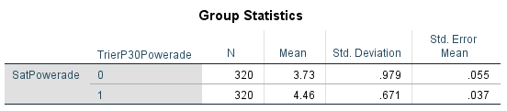

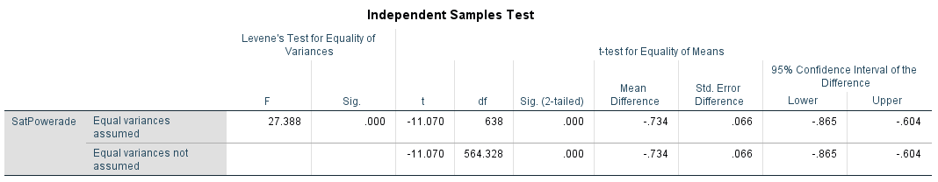

**Age**

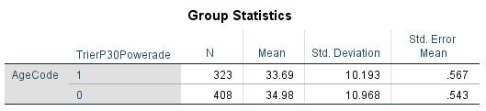

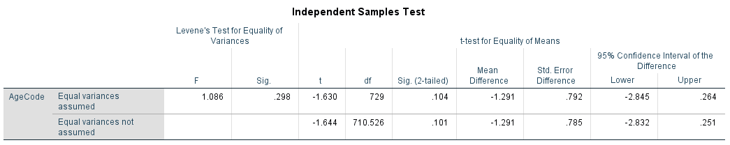

**Income**

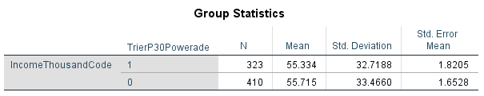

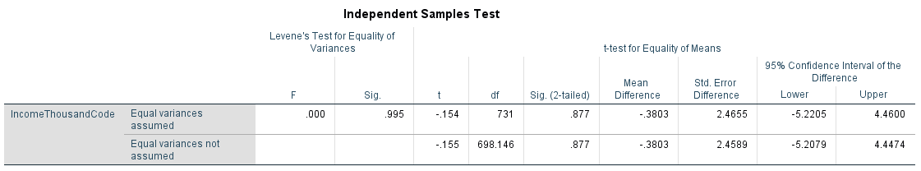

6. Create a single (easy to read) pivot table that compares the mean ratings for the following measures by Gatorade triers versus non triers. Your pivot table, as usual, should show sample size.

* Satisfaction gatorade
* Age (the re-coded variable)
* Income (the re-coded variable)

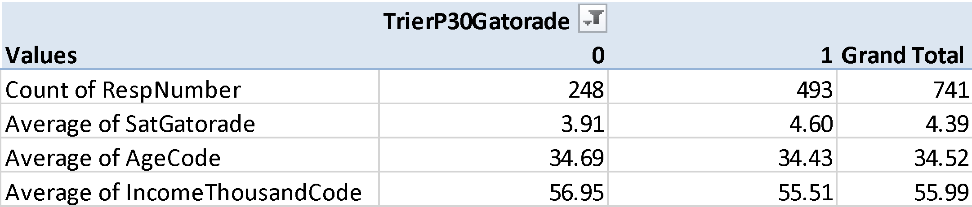

7. Determine if the mean ratings between Gatorade triers and non-triers are significantly different for the following measures. To determine if the mean ratings are different by triers and non triers, use the independent sample t-test

Calculate the t-test for each one below using *analyze/compare means/independent samples t-test****.***

**Be sure to copy and paste the SPSS output that shows the MEAN RATINGS.**

* Satisfaction gatorade
* Age (the re-coded variable)
* Income (the re-coded variable)

For **each of the above measures and hypothesis tests**, what is the null hypothesis? what is the alternative hypothesis? Based on the results, do you accept or reject the null hypothesis? Why?

**Satisfaction:**

* **Null Hypothesis: There is no difference in satisfaction by Gatorade triers and non-triers.**
* **Alternative Hypothesis: There is a difference in satisfaction by Gatorade triers and non-triers.**
* **Based on the results, we reject the null hypothesis and accept the alternative hypothesis because the Sig (2-tailed) data in the SPSS output is .000, meaning we are essentially 100% confident that there is a difference in satisfaction by Gatorade triers and non-triers.**

**Age:**

* Null Hypothesis: There is no difference in age by Gatorade triers and non-triers.
* Alternative Hypothesis: There is a difference in age by Gatorade triers and non-triers.
* Based on the results, we reject the alternative hypothesis and accept the null hypothesis because the Sig (2-tailed) data in the SPSS output is .756, which means we are only 24.4% confident that there is a difference in age by Gatorade triers and non triers.

**Income:**

* Null Hypothesis: There is no difference in income by Gatorade triers and non-triers.
* Alternative Hypothesis: There is a difference in income by Gatorade triers and non-triers.
* Based on the results, we reject the alternative hypothesis and accept the null hypothesis because the Sig (2-tailed) data in the SPSS output is .579, which means we are only 42.1% confident that there is a difference in income by Gatorade triers and non triers.

**Satisfaction**

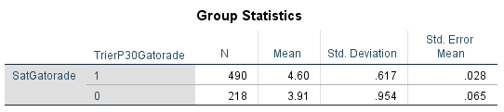

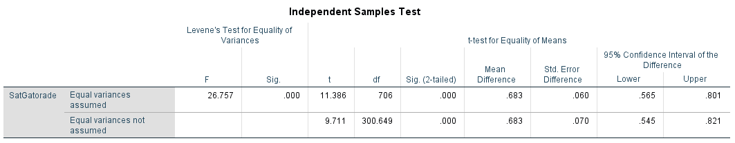

**Age**

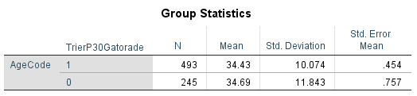

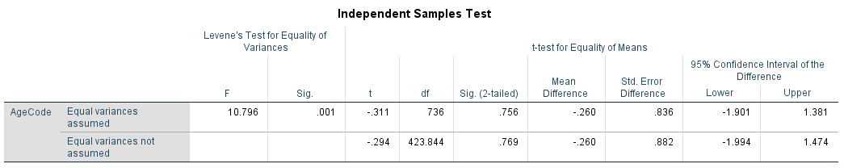

**Income**

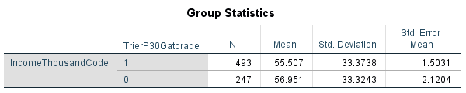

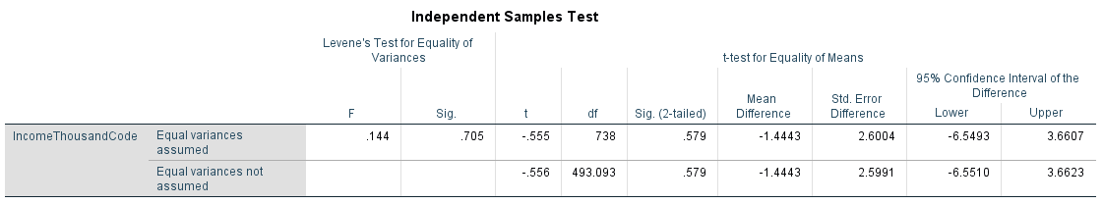

8a. One of the best ways to identify the drivers of success or purchasing is to examine the difference in the attribute ratings by Powerade triers and non triers (i.e restores, endorsement, friends drink, etc). Those attributes with the biggest difference between Powerade triers and non triers are the primary drivers of success/purchasing

First, create a pivot table that shows the mean ratings for all of the attributes by Powerade triers and non trier. This pivot table should be in rank order (from high to low) based on the overall mean rating. Copy and paste your pivot table below (with sample size)

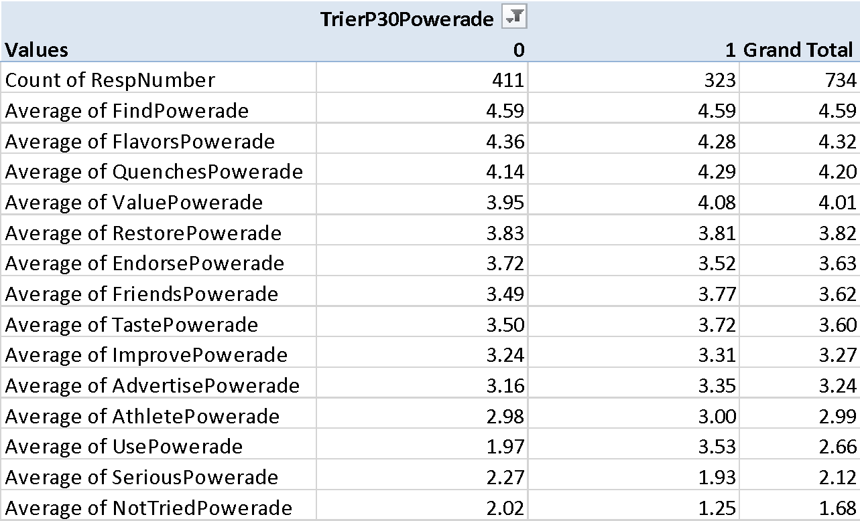

8b. Second, using the independent sample t test, determine which attributes are significantly different by Powerade triers and non triers. Copy and paste the SPSS output below

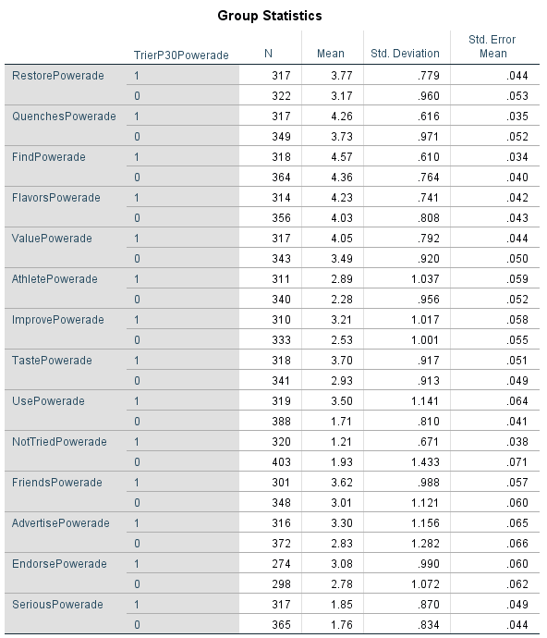

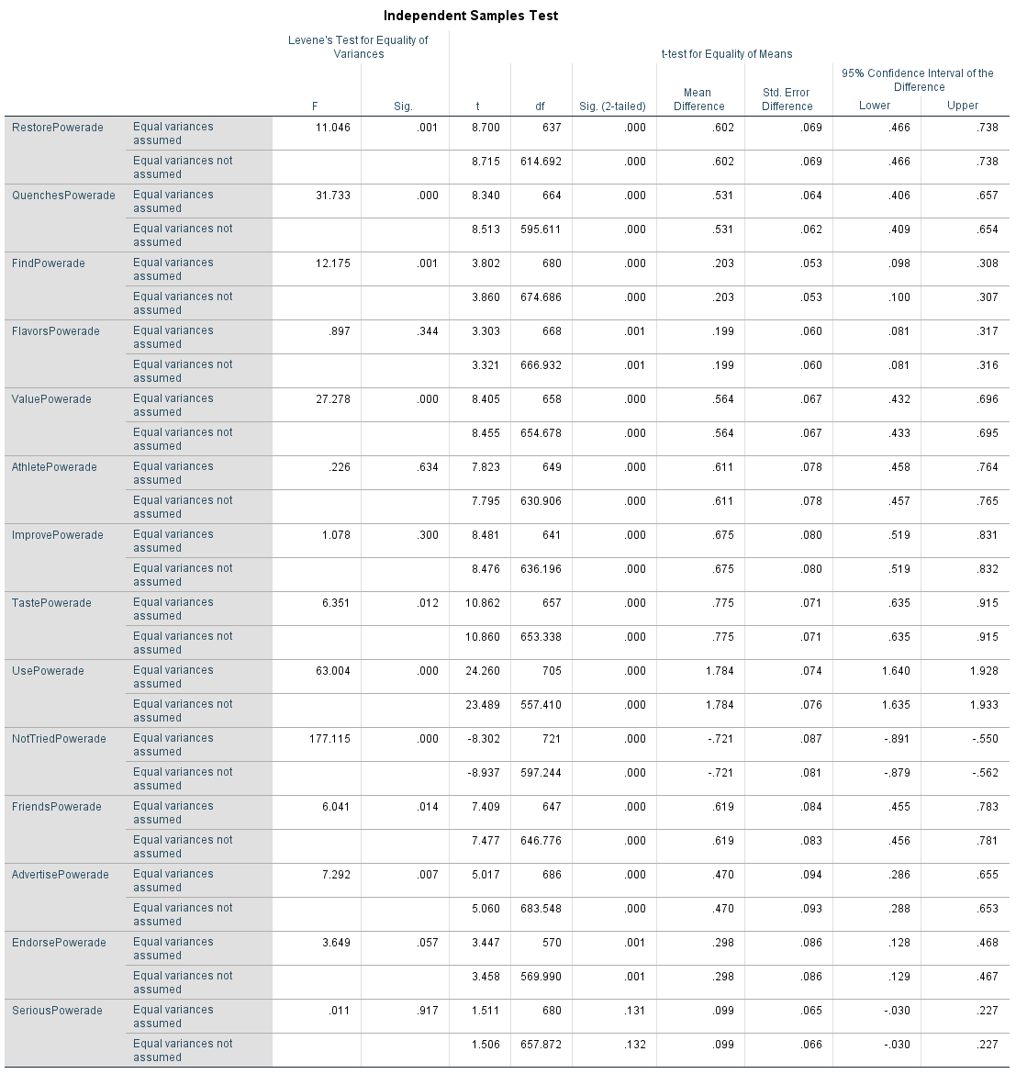

8c. Third, discuss the drivers of success/purchasing for Powerade. Remember your analysis for the results section of the Powerade report!

**To determine the drivers of success/purchasing for Powerade, we looked at the t-test values from the above SPSS data.**

**Looking at the greatest values (disregarding whether they are positive or negative), showed that the two main drivers for Powerade were taste and use (i.e Powerade *tastes* better than other sports drinks; Powerade is a product the customer *uses* regularly).**

**For TastePowerade, the T-test value for the equal variances assumed is 10.862 and the equal variances not assumed is 10.860. The Sig-value is less than .0001, so we can reject the null hypothesis, and conclude that the mean of the non-triers is significantly different than the mean of the triers in regards to the taste of Powerade. Additionally, since the Sig-value is less than .0001 we should look at the equal variances not assumed (T-test value 10.860).**

**For UsePowerade, it is a similar case as TastePowerade. The T-test value for the equal variances assumed is 24.260 and the equal variances not assumed is 23.489.**

**The Sig-value is less than .0001, so we can reject the null hypothesis, and conclude that the mean of the non-triers is significantly different than the mean of the triers in regards to the use of Powerade. Additionally, since the Sig-value is less than .0001 we should look at the equal variances not assumed (T-test value 23.489).**